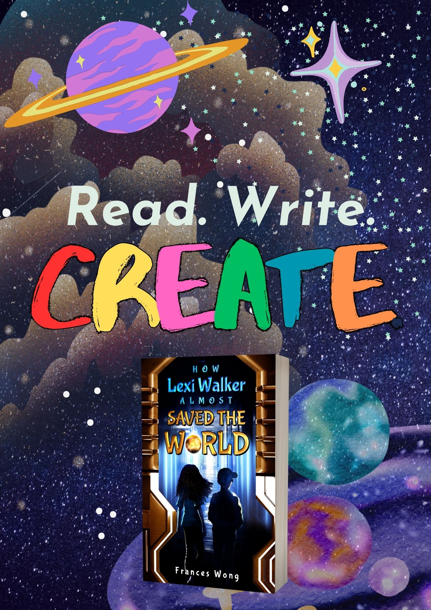

**The Appendix**

# Appendix 1 – Hook Session 1

Mystery QR Code



1

Mystery QR Code



2

Mystery QR Code



3

Mystery QR Code



4

Mystery QR Code



5

Resources for annotating the text:

Lexi gave her skateboard a strong kick and darted between a group of tourists. She watched them quizzically as they all snapped photos of lampposts. It was a particularly dull lamp post, in Lexi’s opinion. It wasn’t even one of the new ones with the fancy LED lights. Why anyone would want a photo of a lamppost, Lexi had no idea.

Lexi gave her skateboard a strong kick and dodged a group of tourists. She watched them quizzically as they all snapped a photo of a lamppost. It was a particularly dull lamppost in Lexi’s opinion. It wasn’t even one of the new ones with the fancy LED lights. Lexi had no idea why anyone would want a photo of a lamppost.

# Appendix 2 – Hook Session 2

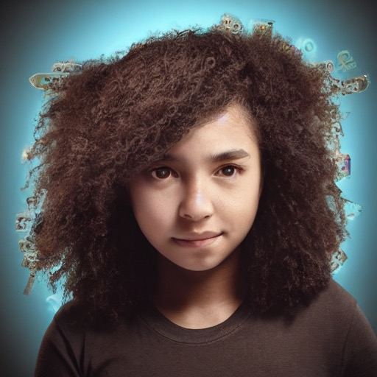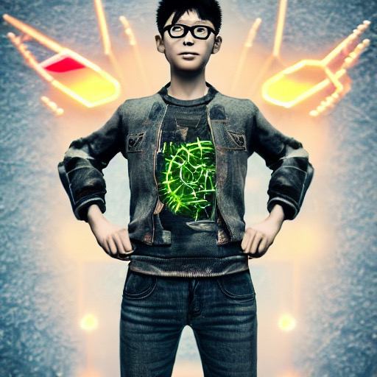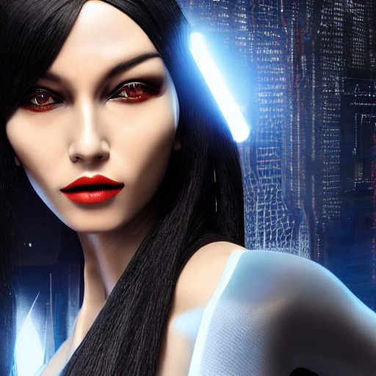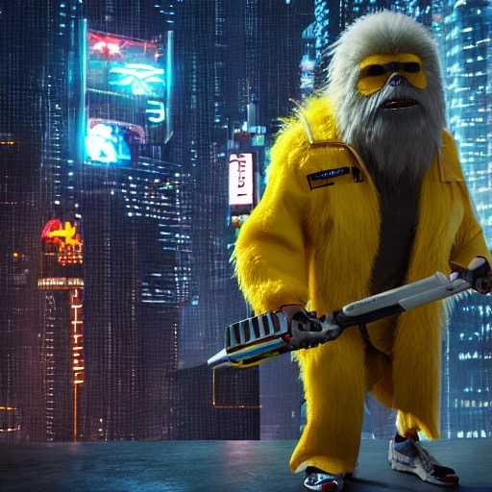

Character Descriptions:

a strange sight on her old fashioned skateboard: jean shorts, curly hair, backpack and pink trainers.

Lexi’s wonderfully curly, brown hair bounced on her shoulders as she skilfully swept round a corner lamppost and onto the next street.

The lady wore a resplendent red coat that danced dramatically in the breeze. It matched her dark, red uniform beneath. Her head was rather small, her eyes were completely black and large. Her jet, black hair was pulled off her face in a tight plait. She reminded Lexi of a cross between a warrior space princess and a Time Lord. Her gloves caught Lexi’s eye. She wore the same, thick protective gloves that Captain Blast was wearing over her coat all the way up to her elbows.

She was short and podgy and very old, judging by her pure, white hair neatly tied up in a thick bun. She was usually dressed all in beige, reminding Lexi of a jungle explorer, except that on her feet she wore bright, pink trainers. Lexi didn’t know of any old people who wore bright, pink trainers, except for Ms Boiko. Her wise, brown eyes sparkled behind little, silver spectacles which she wore perched on the end of her nose. She was watching Lexi very carefully, as if she knew something secret and Lexi was getting closer to finding out what it was.

Tim would never wear bright colours like Lexi. His green trainers were usually hidden under baggy jeans and the rest of him under long TV show T-shirts. He had straight, black hair that he liked to keep short and almost always wore a hat. He pushed his glasses up his nose.

She looked up, and further up to see the voice belonged to the tallest person Lexi had ever seen in her life. He was completely covered in long, shaggy hair, like a bear who needed a haircut, and he wore a scruffy yellow jacket with tools bulging out of it.

What she looks like

Who she is inside

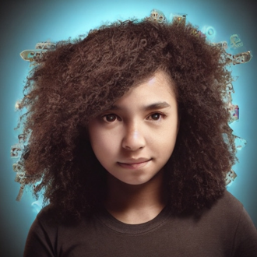

What he looks like

Who he is inside

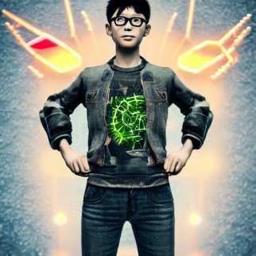

|  |  |
| --- | --- |
| Subject |  |
| Noun Phrase |  |
| Verb |  |
| Add an adverb |  |
| Where? |  |
| Write your sentence here. | |
|  | |

Book blurb:

**Join twelve-year-old Lexi Walker on an epic mission to capture a mysterious Orb and uncover the secrets of her small town! Along with her best friend Tim, Lexi embarks on a thrilling adventure and discovers an incredible alien world hidden beneath the town library. With action-packed chases, heart-pumping thrills, and impossible choices, will Lexi be able to keep her newfound powers a secret, or risk everything to protect the Orb?**

|  |  |  |
| --- | --- | --- |
| Word Bank | | |
|  |  |  |
|  |  |  |
|  |  |  |
|  |  |  |
|  |  |  |

# Appendix 3 – Hook Session 3

|  |  |
| --- | --- |
| Fill in the apostrophes | |
| Lexis skateboard glided smoothly over the pavement as she and Tim raced through the town, the wind whipping through her hair.  Tim's legs pumped furiously as he struggled to keep up with Lexis skateboard, determined to catch the mysterious orb.  The sound of Lexis skateboard wheels clicking against the pavement echoed through the empty streets as they raced towards their goal.  With each passing moment, the mysterious orb seemed to be slipping further out of Lexi and Tims reach, fuelling their determination to catch it.  As they neared the edge of town, Lexis grip tightened on the skateboard, knowing that they were getting closer to uncovering the secrets of the orb. | |
| Mark my work | |
| Tims’ sneakers pounded against the pavement as he kept pace with Lexis’ skateboard, his eyes never leaving the orb that glowed brightly in the distance. |  |
| Lexi's heart raced with excitement and a touch of fear as she and Tim raced through the town, wondering what they would discover when they finally caught the orb. |  |
| As they turned a sharp corner, Lexis’ skateboard narrowly’ avoided a parked car’, and Tim stumbled slightly, but they both recovered’ quickly and kept moving forward. |  |

# Appendix 4 – Hook Session 4

|  |
| --- |
| **Chapter 3 Part 1**  Everything ached. The cast on her broken arm cracked. Lexi’s hands were tingling. Her head pounded. She couldn’t move. Lexi lay still, on her back in the mud, wishing all the pains would go away.  She heard Tim’s footsteps racing towards her.  “Lexi! You’re okay!” he cried. “When I couldn’t see you, I thought ... Oh!” he stopped suddenly, eying Lexi’s hands. His smile faded.  Lexi heaved herself up to sitting. “What?” she asked, “What is i- Oh.”  Clutched between Lexi’s hands, glowing warmly, was the orb. She’d caught it. She stared at the orb as if she couldn’t believe it was actually there. She gripped it so hard that she could see the whites of her knuckles. It wasn’t heavy. It felt as light as a basket ball.  As Lexi dragged herself to her feet, Tim almost flinched away from her but stopped himself before she noticed.  “I caught it,” she announced, not knowing what else to say. She was stunned. Lexi felt as if her stuttering brain was full of cotton wool. Maybe it was the rush of air when she’d grabbed the orb or maybe it was the fall but she didn’t feel like herself at all. Her hands were tingling  Tim pointed an accusatory finger at the orb. “What is it?”  “Quick. Take a selfie. Just in case it flies away.”  Tim tugged Lexi’s phone out of her pocket (long ago, it had been her mum’s phone) and quickly snapped a photo. |
| **Chapter 3 Part 2**  “I’ll take it.”  Lexi span around, edging away from the voice. It belonged to a tall man dressed in a long, dark coat. Tim scurried behind Lexi and gaped back at the man over Lexi’s shoulder.  The man, or whatever it was, looked more like a crocodile standing up on two legs wearing clothes. He had a long face with sharp teeth poking out from his elongated snout. A silver eye patch covered one of his eyes and on top of his bald head, perched a pirate hat pulled down at a jaunty angle.  Immediately, Lexi didn’t trust this creature. She definitely didn’t like him. She glared at the man over the orb.  On his hands he wore thick, tarnished silver gloves that reminded Lexi of safety gloves the blacksmith had worn on a field trip to the museum one day. The gloves went half way up his arm over his coat.  Lexi hadn’t seen where he’d come from. One minute he wasn’t there, and now he was. He was eying the orb in a hungry sort of way. Lexi clutch`ed it tightly to her chest, determined not to let the crocodile pirate man take it.  “Wh… who are you?” she called over to him, trying to sound brave. Thankfully, the man kept his distance. Lexi tried to stand taller and puff out her chest hoping it made her look older and - most importantly – tougher.  With a flourish that made Tim flinch, the crocodile man bowed and introduced himself, “Blast, Captain Blast, at your service.” He placed his hat back on his head. “And now, for your own safety, I’ll be leaving with the Orb.” |
| **Chapter 3 Part 3**  “I caught it,” Lexi declared, not feeling as brave as she sounded. The man looked like a crocodile and he had literally appeared from nowhere. Lexi felt she had somewhat of a right to feel scared and a little defiant. She could feel Tim quivering behind her. “It’s mine. I chased it, I caught it. You can’t have it.”  “Look here, you little…,” Captain Blast snapped, then stopped himself. “You have no idea how dangerous the Orb is. I don’t know how you can hold it like that, or how you’re still alive.”  “What do you mean?” Lexi demanded.  He shook his head, clearly irritated. “Look I don’t have time for this, and you don’t either.” He waggled his silver gloves at Lexi. “See? Safety gloves. Touching that Orb will kill you; I’m not sure why it hasn’t already.” He shrugged. “Maybe it’s delayed in humans, who knows. Sorry, kid, your days are numbered.”  “You’re lying,” Lexi growled. “You’re lying to get me to give you the orb!” Even so, doubt edged her voice.  ‘Maybe. Do you want to risk it?” He stepped forward, deliberately, “You need to give it up. It’s for your own good.”  Lexi gazed at the orb glowing peacefully in her hands. It didn’t seem dangerous. Captain Blast, if that was his real name, was lying and Lexi didn’t trust him one bit.  “If you can’t catch it yourself,” Lexi called over, feeling unusually brave, “Then you can’t have it!”  “Lexi, just give it to him,” Tim hissed in her ear.  “No way,” Lexi hissed back. “Look at him. He’s scared of it. He doesn’t want it for any good reason.”  “I don’t want to hurt you, kid,” Captain Blast warned, reaching for some kind of weapon clipped to his belt.  Lexi started to doubt herself. Maybe Tim was right. Maybe she should just give the crocodile man the orb. Nothing was worth getting hurt over. |
| **Chapter 3 Part 4**  Lexi was about to give the man the orb, when suddenly, with a swoop and a whoosh, a lady dropped from the sky, landing with a magnificent flourish between Lexi clutching the orb and Captain Blast. She was followed by a cat, except that the cat was human sized, walked on two legs and wore a snazzy, blue jumpsuit.  What was going on?  The lady wore a resplendent red coat that danced dramatically in the breeze. It matched her dark, red uniform beneath. Her head was rather small; her large eyes were completely black. Her jet, black hair was pulled off her face in a tight plait. She reminded Lexi of a cross between a warrior space princess and a Time Lord. Her gloves caught Lexi’s eye. She wore the same, thick protective gloves that Captain Blast was wearing over her coat all the way up to her elbows. Was she planning to take the orb too?  “Lexi,” Tim whispered in her ear, his voice shaking. “They’re aliens.”  Aliens. It all made sense now! A crocodile man, a cat man, the lady with the really small head and enormous eyes. They were aliens! Real aliens and they were standing here on the playing fields behind Lexi’s house. They were so close, she could reach out and touch them. This was incredible!  “That’s enough, Blast,” the woman in the red coat ordered. “Back away from the Orb, before I make you back away.”  “I want that Orb, Eltran.”  What had Lexi and Tim stumbled onto? What were they in the middle of? Lexi couldn’t wait to find out.  The lady, Eltran stood firm between Lexi and Blast. “That is not going to happen. It's under my protection.”  Blast smiled his crocodile grin at Eltran. “The human is holding the Orb in her hands. Her bare hands. And she’s not dust.”  Forgetting all about Captain Blast, Eltran and the cat man span on the spot, staring wide-eyed at Lexi, which was quite unnerving because Eltran’s eyes were already wide. Eltran’s gaze moved from Lexi’s face to the orb, as if she couldn’t believe what she was seeing. Lexi thought that was strange as she was the alien, after all. She must have seen a thousand strange things more interesting than Lexi’s hands. |

|  |
| --- |
| **Chapter 3 Part 5**  Lexi gasped. “He’s getting away!” she cried, pointing as Captain Blast chose that exact moment to disappear.  “He won’t go far,” the cat man dismissed.  “Morz, get the cage,” said Eltran, her voice firm. Lexi didn’t like the sound of that. To Lexi, Eltran said, “I’ll take that now, thank you. Carefully, if you please.”  Lexi hesitated, not knowing what to do. She didn’t want to give Eltran the orb. But at the same time, Eltran seemed to be a sort of intergalactic police officer. She was wearing a uniform, and she had a badge. Lexi’s parents had always taught her to respect police officers. Lexi felt torn. She didn’t want to break space law but she had caught the orb all by herself. It was hers… and Tim’s of course.  When Lexi hesitated, Eltran yelled, “Can you hear me? Is my translator broken again?” She tapped the shiny badge on her chest. “Give. Me. The. Orb.” She shook her head in irritation. “Where is Morz with that cage?”  “You can’t put us in a cage.” Lexi was indignant as she finally found her voice.  “The cage isn’t for you,” said Eltran, moving aside as the cat alien, the one she’d called Morz, returned with a metal box that floated in the air beside him. It was just big enough for the orb. Streaks of blue light zapped across the surface. ”Place the orb inside the box.”  Lexi took a step back. “No, it’s mine,” she said for the second time that day. She couldn’t give the orb away, not now. Not when she was so close to finding out what was going on. She needed to know what that spinning blue smoke had all been about, and why it had said her name.  “Now.”  Lexi screwed her lips up tight and took another, deliberate step away from the box with the blue flickers of light flashing like lightning up the sides.  Eltran glowered. “The Orb is the property of the Galactic Union,” she told them in an officious tone. “I am Officer Eltran, a Ranger for the Galactic Union.” She showed Lexi her badge. It glowed blue and a small hologram of Officer Eltran rotated on it, looking so real Lexi would have really believed it was a real life mini-Officer Eltran. “You will do as I say or face serious consequences.”  When Lexi didn’t move, Morz bellowed, “This isn’t a game, kid! The Orb of Erudite is dangerous, it’s deadly and it is not intended for little human children who have no idea what they getting involved in.” Unfortunately, Morz was completely wrong but he didn’t know that yet.  “That’s enough, Morz,” Officer Eltran said firmly. “Look, human, in a few days, every orb hunter in the galaxy will be here and they won’t be anywhere near as nice as I am. Put the Orb of Erudite in the box before you hurt yourself, or anyone else.”  Stunned and a little frightened, Lexi froze. Officer Eltran’s expression was exactly the same as Lexi’s mother when she’d been in a temper. Lexi’s feelings twisted all up inside her. In that instant, Officer Eltran snatched the orb from Lexi’s hands and dropped it smartly into the box. There was nothing Lexi could do! Morz snapped the lid shut.  The orb was gone.  Lexi tried to shout, to say something, to make them give the orb back but the words stuck in her throat. Lexi’s thoughts began to tangle. Officer Eltran thought Lexi could hurt someone with the orb? Lexi would never hurt anyone! What could Officer Eltran mean? Lexi was almost scared to find out.  The officer reached inside her magnificent coat. “Now, to erase both of your memories,” she muttered.  “No, wait,” Lexi pleaded. “What is the orb? Why is it here? Why does it keep coming back? What did it want with me?” She felt as if she couldn’t ask all the questions she wanted to before she ran out of time.  Officer Eltran didn’t look as if she was going to answer. Instead, she pulled a small, white disc from her inside pocket. “Ah, here it is.” She held it in front of Tim’s face. Tim looked at Lexi, his eyes filled with terror.  “No, please don’t,” Lexi begged. “We don’t want to forget.”  “It’s for your own good.”  The last thing Lexi saw was a flash of white light before everything went black. |

## Sample Text

How Lexi Walker Almost Saved the World

With a perplexed frown and a hand on my hip, I gazed upward, trying to understand the enigmatic thing hovering sightlessly above me. The hair on the back of my neck prickled with anticipation, but I refused to look away. My mind raced with possibilities, each thought a fleeting shadow, as I pondered how to capture this elusive light. It was magical, otherworldly, and I was determined to catch it.

With a swift flick, I kicked off my skateboard and bolted out of the alley, dodging past groups of tourists as I pursued the mysterious light, my heart racing with excitement. Was it a ball of light? Or something else entirely? I had to catch it, to unravel its secrets. I darted through the bustling streets of Rosewell, sliding around corners, pushing harder and faster, a glimmer of excitement in my eye. I was halfway there, and I couldn't afford to lose sight of it.

An alarm chimed on my phone, and I glanced away, just for a moment. But that was all it took. When I looked back up, the light had vanished, leaving me standing there, bewildered and annoyed. I kicked my skateboard into a nearby bin, cursing under my breath as I checked my phone, realising I was late - again.

But this time, I had a good reason. For once, the Mystery Hunters had a genuine mystery to solve, and I was bursting to share my discovery with my best friend and fellow detective, Tim. I hopped back on my skateboard and raced through the streets, determined to make up for lost time.

Dodging past crowds of tourists and bewildered locals alike, I marvelled at the oddities of Rosewell and its strange visitors. Why did they all seem so fascinated with mundane objects like lamp posts and street signs? I pondered this as I raced past them, determined to reach Tim before he could scold me for being late - again. As I skidded to a stop outside our usual meeting spot, I grinned with anticipation. This was going to be the best Mystery Hunters meeting yet.

As I skated into Tim's garden, his grumbling voice filled my ears. He was like a shadow, always dressed in dark colours, hiding behind his long TV show t-shirts and baggy jeans. His green trainers were a rare pop of colour that I admired. He pushed up his glasses and shuffled his feet, a picture of discomfort.

Tim tried to sound casual as he asked, "Where does your uncle think you are?"

I rolled my eyes, "Like he cares where I am. Anyway -"

Tim hesitated before saying, "You don't talk about your parents much anymore." His discomfort was palpable, and I knew his mums had insisted he talk to me about this. But I couldn't bring myself to talk about the painful memories of the car crash and the nightmares. So, I pushed down my emotions and smiled instead.

Taking a deep breath, I redirected the conversation, "Right, Tim, I've been investigating and -"

Without missing a beat, Tim declared, "I declare the seventeenth meeting of the Mystery Hunters open," and opened his notebook. I felt relieved that I didn't have to talk about my parents. It was just the two of us in the shed, and that was exactly how I liked it.

Quickly seconding his declaration, I exclaimed, "Listen, Tim! I literally just spotted this thing in the sky. An orb, or something. You know, like those lights you get on photographs sometimes? But... this time, it was in real life." I leaned back, pleased to see the excitement in Tim's eyes.

“That’s odd,” Tim said, furrowing his brow.

“I know,” I agreed, “and -”

“No, I mean, it really is weird,” Tim insisted, “because my cousin saw the same thing. By the playing fields, yesterday.”

“Did he indeed?” I said, feeling a thrill of excitement. “This is it, Tim. Our chance to uncover Rosewell’s secrets!”

Tim rolled his eyes. “Here we go again with the destiny stuff.”

Ignoring his scepticism, I grabbed Tim’s wrist and pulled him out of the clubhouse. “We can’t discover the truth by sitting in a shed all day. Let’s go find it!”

As we arrived at the playing fields, I scanned the sky eagerly, searching for any signs of the mysterious light. The air was filled with joyful screams, but no orbs could be seen.

Tim and I settled onto a hill and gazed up at the sky, occasionally checking the time and recording our observations. Suddenly, a deep grumbling sound filled the air, growing louder and louder.

The breeze turned into a gust, and a thunderous roar echoed across the field. Looking up, I saw two suns shining against the blue sky - the strange light we had been searching for!

|  |  |  |
| --- | --- | --- |
| Vocabulary Quick Quiz | | |
| perplexed |  | follow or chase (someone or something). |
| decipher |  | difficult to find, catch, or achieve |
| elusive |  | succeed in understanding, interpreting, or identifying (something) |
| pursued |  | completely baffled; very puzzled. |

|  |
| --- |
| Add inverted commas to the dialogue |
| What do you think it is? Tim asked.  I know what we need to do, Lexi told him, We have to catch it.  Let’s go! Tim cried. |

|  |  |  |
| --- | --- | --- |
| Direct Speech | Reported Clause | Additional Information |
| Where are you going? | Tim asked | as Lexi walked away. |
|  |  |  |
|  |  |  |
|  |  |  |
|  |  |  |

Extract from Chapter 4 – Highlighting Dialogue

“Tim,” Lexi hissed, glancing over his shoulder into the house to check no one else was listening. “Tell me you remember what happened yesterday?”

That was a weird question. “Well, the bus was late and Mrs Western moaned at us for getting to her English lesson late…”

“Tim, that was Friday.”

He nodded. “Yeah, yesterday. Today is Saturday.” However, the look on Lexi’s face made him doubt himself.

Lexi waved a hand in front of Tim’s face, staring at him. He didn’t like the way she was peering at him, like he was a bizarre experiment.

“What did they do to you?” she asked, amazed.

Tim did not like the sound of this one bit. “What did *who* do to me? And where is your plaster cast?”

“You don’t remember yesterday *at all*?”

Tim’s heart began to race. The backpack in the hallway, Lexi’s arm, things were not adding up and now, Lexi was acting strange. Stranger than normal, anyway. A sinking feeling swamped Tim and his legs felt like jelly.

“Lexi, what is going on?” he asked in a wibbly, nervous voice.

“Tim, they’ve made you forget that Saturday even happened.” She gave him a quick rundown of the day, then when Tim started to shake his head in disbelief, she held up her phone with a photo on the screen. Tim saw a photo he didn’t remember taking of himself and Lexi standing on the playing fields and there, in Lexi’s hands, was a mysterious, glowing orb.

Tim stared, dumbfounded, at the selfie on Lexi’s phone. He couldn’t remember any of it. Everything Lexi had told him seemed to have happened to someone else.

Tim started to feel anger growing like a tiny fire inside him. Why did aliens think it was okay to change him like that? To steal his memories. They were *his* memories.

“They said it was for our own good.”

Tim handed Lexi back her phone. “But, you remember everything.”

“Yeah,” Lexi agreed. “But, there’s also *this*.”

Lexi held out her hands, palms up, and Tim gasped. Lexi’s hands glittered. They sparkled and twinkled as if they were covered in thousands of tiny diamonds. He’d never seen anything like it.

“Your hands,” Tim began. “I… you… what…? Is that why your arm isn’t broken?”

“I have no idea! But it doesn’t hurt at all. Look.” Lexi waggled her arm to prove it. “I’ve washed my hands fifty times, but I can’t get the glitter off.” She rubbed her hands absentmindedly on her jeans. “I think it’s from the orb.”

# Appendix 5 – Hook Session 5

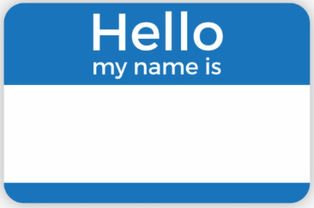 

|  |
| --- |
| Simile and Metaphor Word Bank  Tim  Lexi |
| * The walls towered over me like monolithic giants. * The jagged edges of the walls resembled teeth ready to clamp down on any unsuspecting intruder. * The floor beneath my feet felt slick and slimy, like walking on a freshly caught fish. * The silence was deafening, broken only by the soft sound of my own footsteps echoing off the walls like a timid mouse scurrying for cover. * The air was thick and heavy, like a wet blanket wrapped around my face, making it difficult to breathe. * Strange symbols etched into the walls seemed to glow with an eerie blue light, casting long shadows that stretched out like the tentacles of some unknown creature. * Every step I took felt like a leap into the unknown, as if I were exploring an alien planet where danger lurked around every corner. * The corridor was like a maze, with twists and turns that seemed to lead nowhere. * The atmosphere was charged with an otherworldly energy, like standing in the eye of a cosmic storm. * The walls seemed to pulsate with a strange, otherworldly glow, like they were alive and watching my every move. |

|  |
| --- |
| WAGOLL (What a good one looks like) |
| As I cautiously stepped into the unfamiliar corridor, the walls towered over me like monolithic giants, their jagged edges resembling teeth ready to clamp down on any unsuspecting intruder. The floor beneath my feet felt slick and slimy, like walking on a freshly caught fish.  As I moved forward, the silence was deafening, broken only by the soft sound of my own footsteps echoing off the walls like a timid mouse scurrying for cover. The air was thick and heavy, like a wet blanket wrapped around my face, making it difficult to breathe.  As I looked around, strange symbols etched into the walls seemed to glow with an eerie blue light, casting long shadows that stretched out like the tentacles of some unknown creature.  Every step I took felt like a leap into the unknown, as if I were exploring an alien planet where danger lurked around every corner. I felt like a tiny ant wandering through a vast, unknown world, where even the smallest misstep could lead to my demise.  Despite the fear that gripped me, I couldn't help but feel a sense of wonder and awe at the strange and mysterious world I found myself in. Each step brought me closer to discovering the secrets of this strange, alien corridor, and I couldn't wait to uncover what lay ahead. |

# Appendix 6 – Hook Session 6

|  |
| --- |
| Highlight the expanded noun phrase in this text and correct the mistakes. |
| The warm, magical light emanating from the orb bathed everything in its path with a soft, enchanting glow that seemed to breathe life into the cold dark world around it. It was as if the very air itself was charged with a vibrant, otherworldly energy that permeated every fiber of my being.  The orb seemed to pulsate with a gentle, soothing rhythm, like the beating heart of the universe itself. It was a symbol of hope and inspiration, a bright warm beacon of light in the deep, swallowing darkness that reminded us all of the enchanting mysterious magic and wonder that existed in the world. |



|  |  |  |
| --- | --- | --- |
| metaphors |  | Similes |
|  |  |  |

|  |  |  |
| --- | --- | --- |
| metaphors |  | Similes |
|  |  |  |

# Appendix 7 – Explore Session 1

Find and Write

|  |  |  |
| --- | --- | --- |
| **Elements Of Story Telling** | **Examples In The Text** | **My Own Example** |
| Expanded noun phrases |  |  |
| Fronted adverbials |  |  |
| Subordinate conjunctions |  |  |
| Interesting verbs |  |  |
| Questions for the reader |  |  |
| Speech |  |  |

# Appendix 8 – Explore Session 2

Fill in the gaps using the suggested language types.

|  |
| --- |
| **Expanded noun phrase** |
| I gazed upwards, trying to understand the ______________,  ______________ hovering sightlessly above me. |
| **Fronted adverbial** |
| _______________________, I kicked off my skateboard and bolted out the alley. |
| **Post modifier** |
| The alarm chimed on my phone which was ______________________. |
| **Simile** |
| It zoomed off like a _______________________________________. |

|  |  |
| --- | --- |
| Words I’d like to use in my own writing | Phrases I’d like to use in my own writing |
|  |  |
|  |
|  |
|  |
|  |
|  |
|  |
|  |
|  |
|  |

# Appendix 9 – Explore Session 3

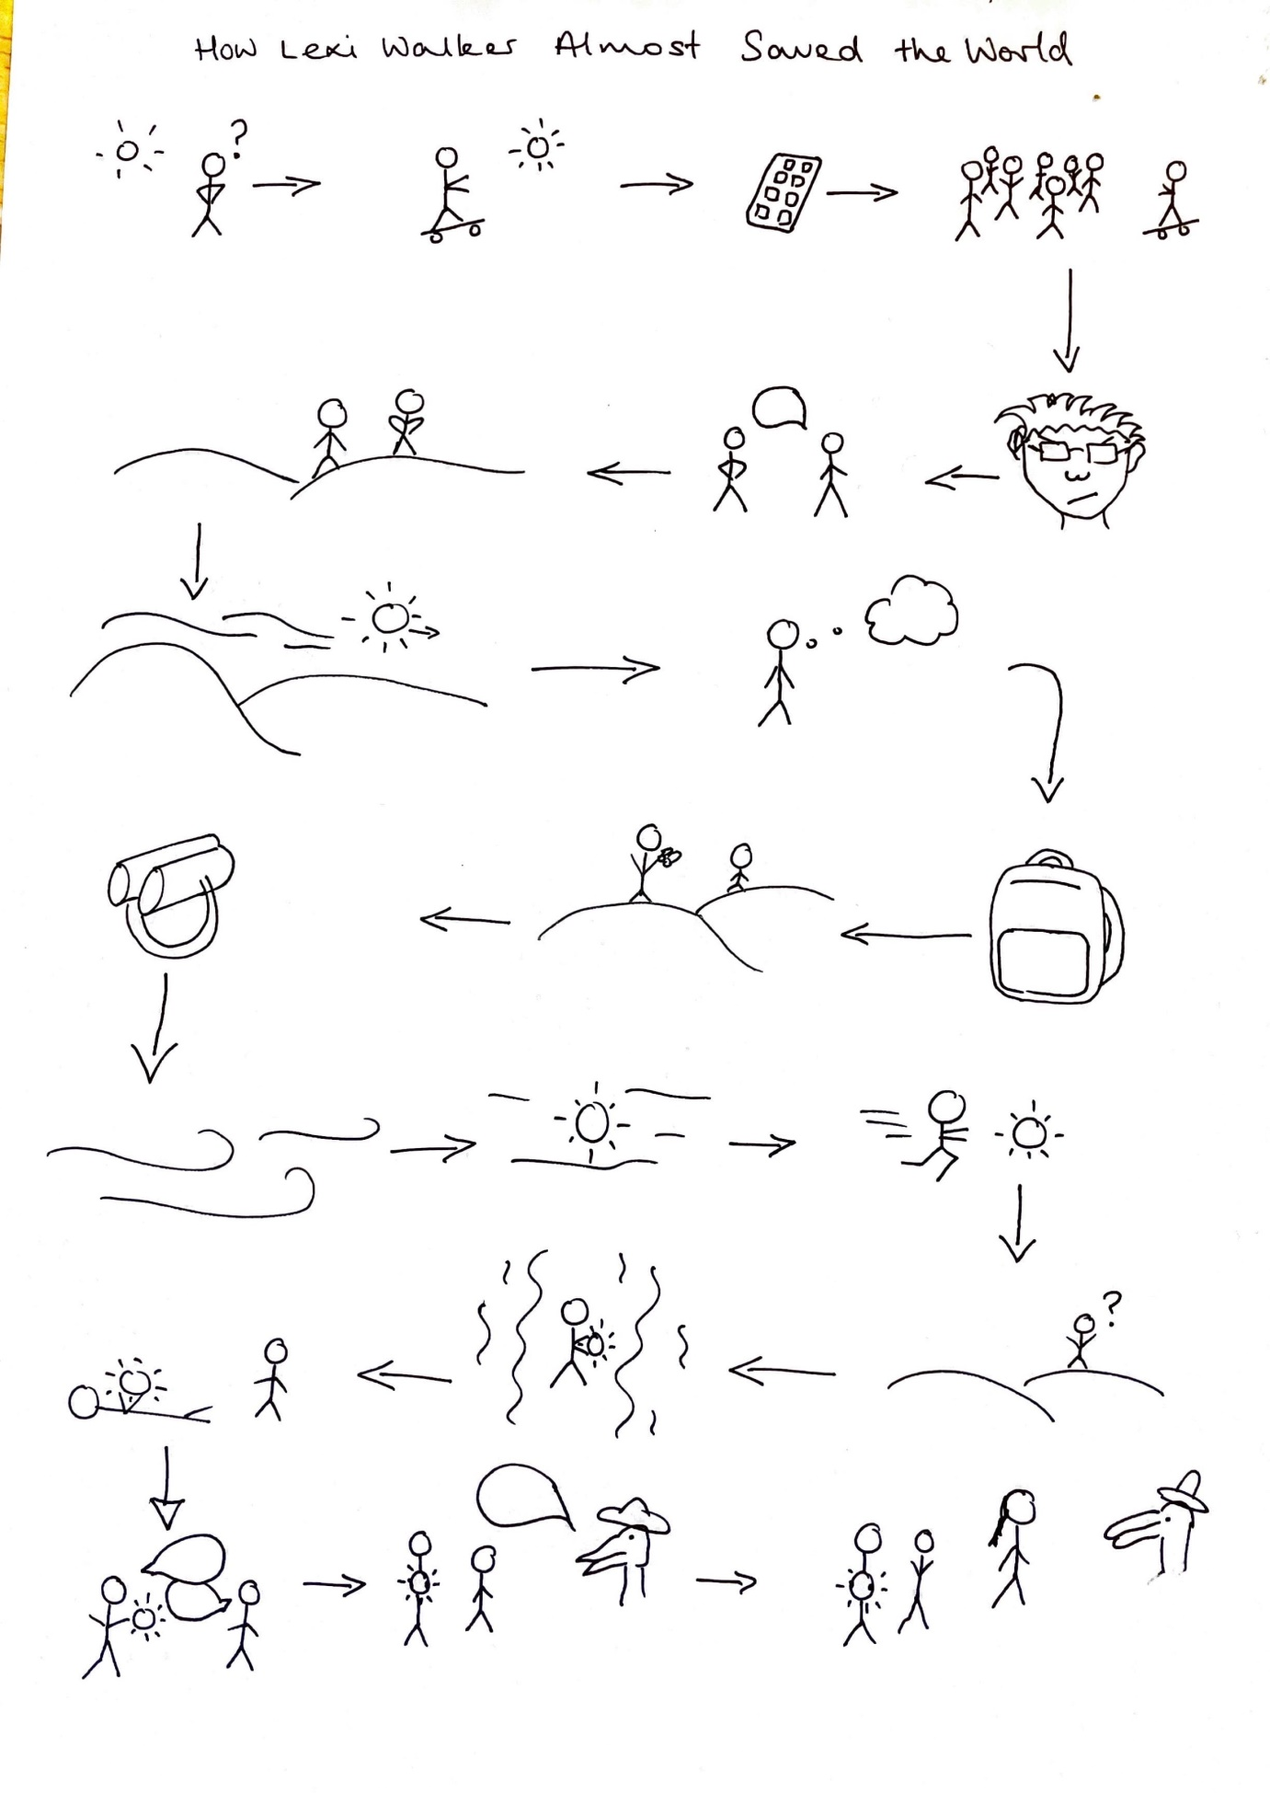

# Appendix 10 – Plan Session 1

Lexi span around, edging away from the voice. It belonged to a tall man dressed in a long, dark coat. Tim scurried behind Lexi and gaped back at the man over Lexi’s shoulder.

The man, or whatever it was, looked more like a crocodile standing up on two legs wearing clothes. He had a long face with sharp teeth poking out from his elongated snout. A silver eye patch covered one of his eyes and on top of his bald head, perched a pirate hat pulled down at a jaunty angle.

Immediately, Lexi didn’t trust this creature. She definitely didn’t like him. She glared at the man over the orb.

On his hands he wore thick, tarnished silver gloves that reminded Lexi of safety gloves the blacksmith had worn on a field trip to the museum one day. The gloves went half way up his arm over his coat.

|  |
| --- |
| **Tim** |
|  |
|  |
|  |
| **Captain Blast** |
|  |
|  |
|  |

|  |  |
| --- | --- |
|  |  |

# Appendix 11 – Plan Session 2

|  |
| --- |
| Description of the playing fields:  When they arrived at the playing fields, they found it packed full of people enjoying the last moments of the warm, summer sun. Playful screams filled the air but Lexi spotted no sign of a mysterious orb. |

|  |
| --- |
| Description of the Hub:  Lexi wished she could look everywhere at once, taking in the wondrous sight that lay before her. With each step she saw something more wondrous and completely impossible. Each step was a new discovery of the impossible.  The entire place was filled with aliens. There had to be hundreds, or maybe even thousands of them. Every alien was a different size, a different shape, a kaleidoscope of colours wearing all sorts of different clothes, some incredibly elaborate or, in some cases, no clothes at all. Lexi looked away, grinning.  Tim bumped into the back of her, gawping at the incredible sight.  Lexi breathed a sigh of relief. He’d come with her.  The Hub was a symphony of movement. Absolutely everywhere was busy and bustling. Everything was moving: the people, their luggage, signs on the walls showing adverts, all of it.  A light shone from the ceiling like sunlight but Lexi knew that was impossible. They were underground. Everything in the Hub was bright and light and clean. Lexi gazed in all directions at once, trying to decide where to go first.  She saw shops everywhere of every kind, a wonderland of gadgets and gizmos, and walking between them, people – aliens – doing their shopping. An alien with tentacles poking out of her clothes scuttled past angrily muttering to her friend.  “Fifteen credits for an antimatter chemostapler. They’re half that back home. I’m not paying tourist prices! Honestly, I ask you.”  “Look up there!” Tim gasped.  The air above them swarmed with tiny robots zipping about. Lexi wondered how all those robots could fly so fast without hitting anyone or anything, or each other. They flicked about in the air like enormous humming birds, carrying packages, or strange, blue rectangles and hovered next to people as if passing a message or delivering a parcel with incredible speed and precision.  Then, as if in a dream, they were approached by a metal man.  “Excuse me,” he said. He was eerily human except completely made of metal. Lexi had to fight the urge to touch the robot. “Could you point me towards someone who could fix my particle circuit?” the robot asked.  Lexi grinned the most enormous grin she’d ever grinned while Tim stared on in silent awe. A *robot* was talking to them! Lexi eyed Tim, knowing about his love for all things robotic, and he was just as star struck as she felt.  “Are your translators malfunctioning?” the robot asked, politely. “Do. You. Understand. Me?”  Lexi pointed. “It’s that way,” she lied, reluctantly, then grabbed Tim and sped off in the opposite direction.  “Wow! Did you see that robot?” Tim gasped. “And a particle circuit. That’s the thing that, well, I mean, I’ve only read about it on the internet. Lexi, things that are still just ideas on Earth are *real* in the alien world.” He shook his head as if he could hardly believe it himself. “It’s like science fiction but it’s real. This is real life and robots are walking around just like you and me!” Tim couldn’t take his eyes off them.  Lexi gazed into every window and peeped through each open doorway. The nearest shop boasted *HyperCoil Mainframes – All Speeds and Configurations – Free Fitting!* on a sign above the window.  A tall alien scurried past them grinning. “They had dry paw cream here. On Earth! No, I can’t believe it either!” she told a shining blue rectangle she held out in front of her face like she was on a video call.  Tim had to duck and dodge as aliens atop blue-edge hoverboards sailed expertly overhead. He dodged around other aliens tugging cuboid suitcases floating above them like helium balloons. An alien beside Lexi stood on a disc of light and floated to an upper floor as if it was a personal elevator. Tentacles dangled down from the higher levels, flicks of light floated in the air. Lines of suitcases, packages, strapped up cargo floated up to spot lights in the ceiling as if they were being abducted by aliens. Tim felt as if he was walking through a science fiction film. None of this felt real, but it was. It was there, right in front of them. |

Draw and describe

# Appendix 12 – Plan Session 3

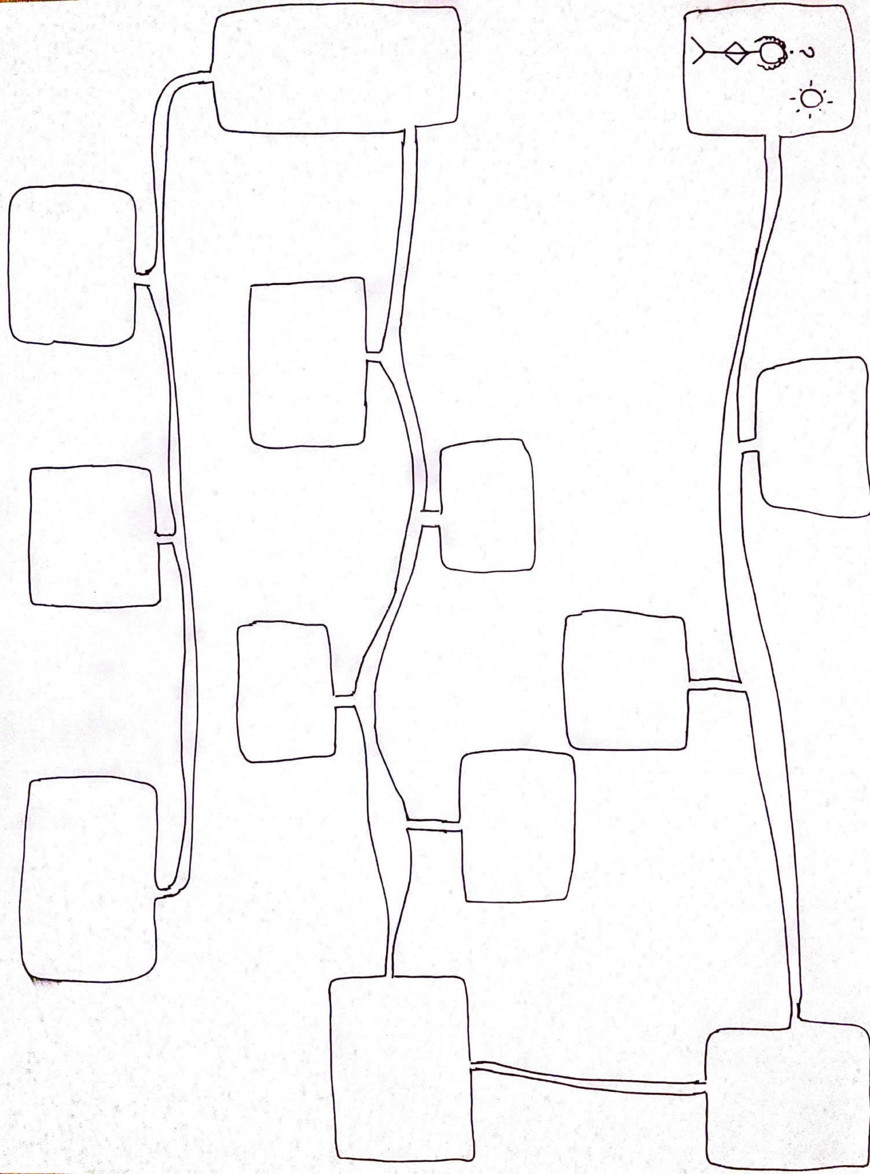

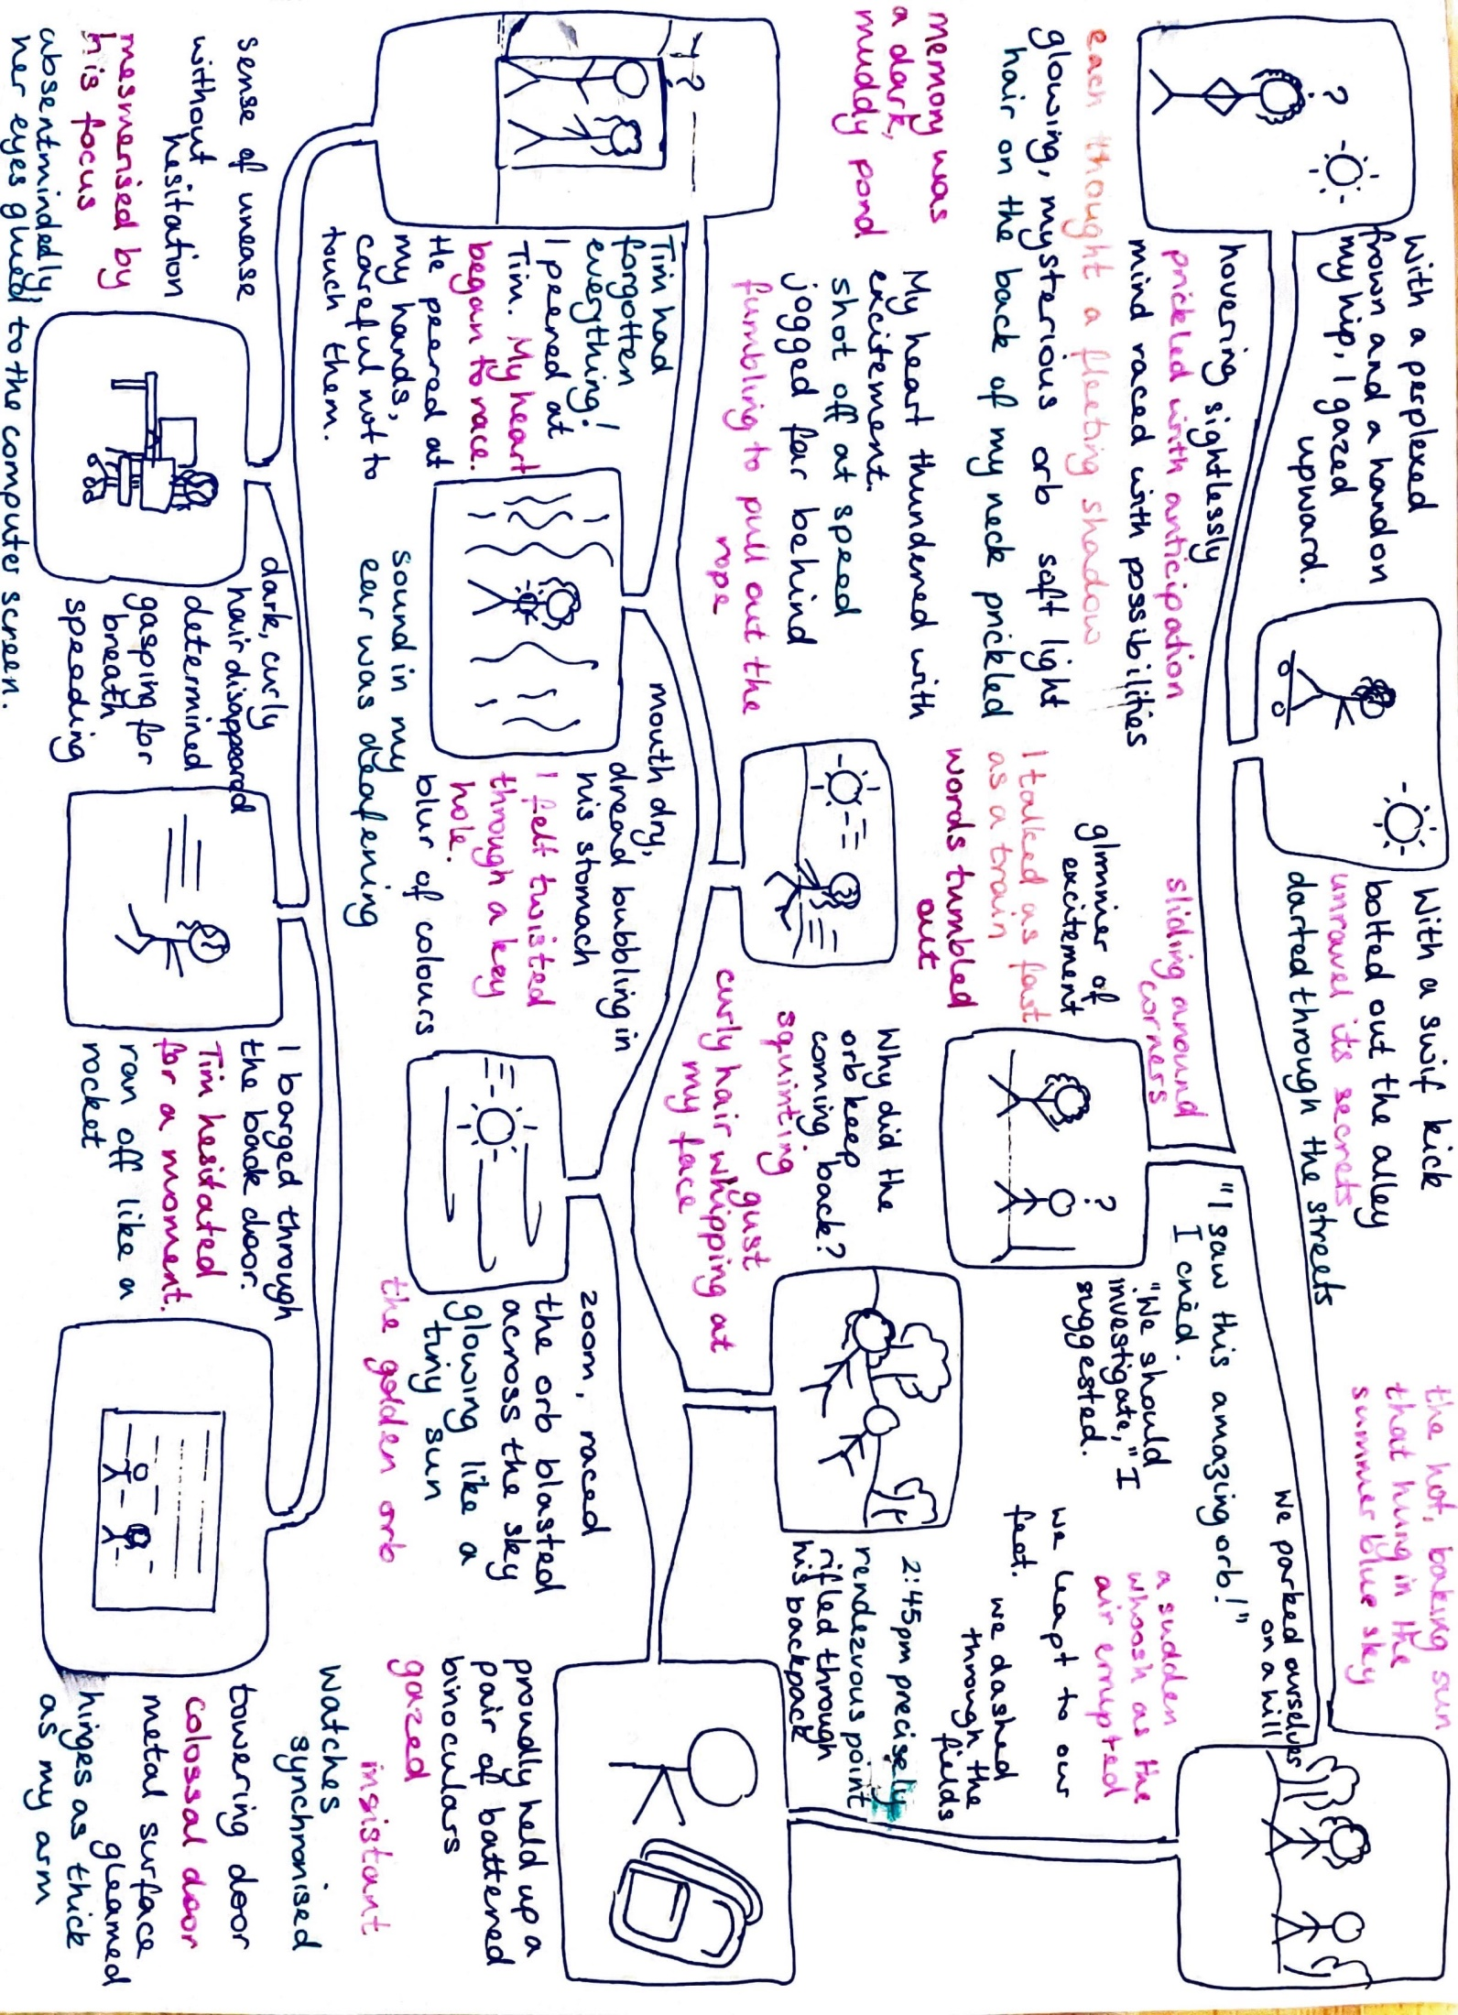

# Appendix 13 – Write Session 1

Writing checklist

|  |  |
| --- | --- |
| **Element to use** | **Have you used it?** |
| First person |  |
| Expanded noun phrases |  |
| Fronted adverbials |  |
| Subordinate conjunctions in the middle of a sentence |  |
| Subordinate conjunctions at the start of a sentence |  |
| Interesting alternative verbs |  |
| Emotion words, or showing emotions through description |  |
| Questions for the reader |  |
| Speech and inverted commas |  |
| Use of paragraphs |  |

